# O2 Prediction Model Research Draft

A VO2 max prediction model designed by Firstbeat validated their model to be 95% accurate for running and a slightly lower accuracy of 92% for cycling (FirstBeat, 2014). The cycling data was validated from a sample of 29 participants freely cycling with heart rate data collected. In this study it was noted that HRmax calculation was done by the age-based method. The actual math of the model was omitted from the research but the features included age (to calculate HRmax), heart rate, and speed to estimate the subjects VO2max.

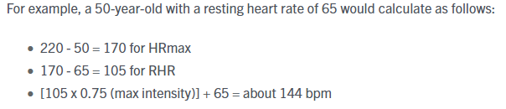

Although research has shown that female HRmax is overestimated from this equation as it was based on a male standard with research showing that the following equation is a better representation for women: 206 – 0.88*(age). Consequently, it would shown that greater deviation from true HRmax was detrimental to the accuracy of the VO2max prediction with an underestimate of 15/bpm increasing the error to 9% and a lesser effect of overestimation of 15/bpm increasing the error to 7%.

It is important to differentiate between VO2max and oxygen uptake. The algorithm predicting VO2max is extrapolating current power, heartrate, VO2 in a submaximal effort or maximal effort to estimate the persons peak capacity of oxygen uptake. The feature set to predict VO2max and also oxygen uptake is likely very similar. However, our current model includes additional features that are not included by the model constructed by Firstbeat.

HRV4Training is an exercising companion application which has built a prediction model for estimating VO2max (Altini et al., 2017). The data being used is predominantly triathletes so this data including cycling information. This model uses age, BMI, gender, average power, average heart rate and resting heart rate as predictors of VO2max in a multiple linear regression mode. This model achieved a R = 0.9 on cross-validation. https://www.hrv4training.com/blog/vo2max-estimation-for-cyclists-in-hrv4training-a-new-data-driven-approach

To see how the O2 algorithm performed on new data a set of Cycling data from Kaggle was used to evaluate the accuracy with a larger set for training and testing. The dataset contains data looking at the physiological response to high-intensity cycling. To keep the test consistent, the columns for blood lactate and saturation were excluded from the feature set but the relationship was explored initially to see potential interactions for future research.

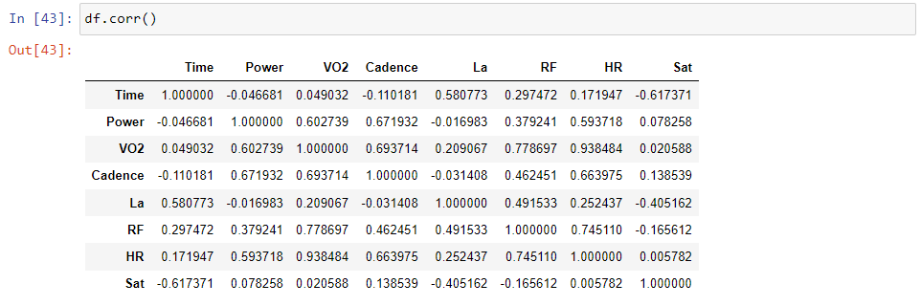

With VO2 we can see that it has a strong relationship with HR (R = 0.94), and a strong to moderate relationship with RF(R = 0.78), Power(R = 0.67), Cadence(R = 0.60) respectively. Blood lactate (La) and Sat.

# Validating models built for O2 prediction

Using a larger dataset collected from Kaggle with the same features we want to see how the models hold up in their ability to predict VO2.

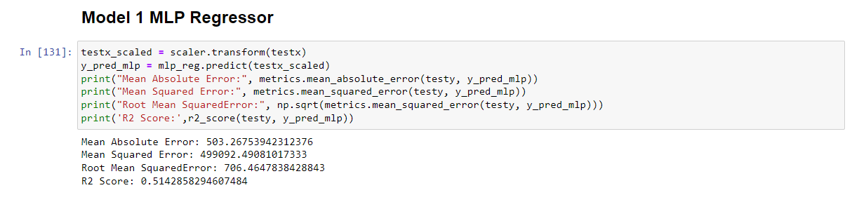

Above shows the performance of the MLP Regression model. As we can see the RMSE when testing the dataset has increased from RMSE = 155.44 to RMSE = 706.46. To keep the metrics consistent, I am also including R2 score to represent the model’s performances. For model 1 the R2 score = 0.53 which is a significant decrease in accuracy.

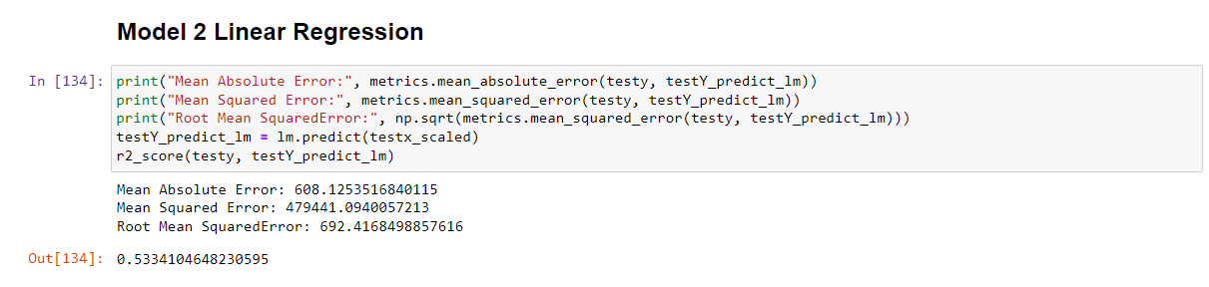

The linear model had comparable results from the first model with RMSE = 692.42. For this model the R2 score = 0.53 as opposed to R2 score = 0.98 on the original data the model was built on. As we can see, the accuracy has fallen off for the linear regression model as well.

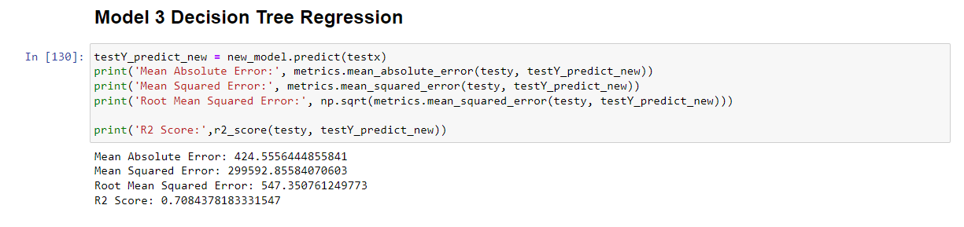

Lastly is the Decision Tree Regression model, this model returned the follow score: RMSE = 547.35. The R2 score = 0.71 compared to R2 score = 0.99. From these results they indicate that Model 3 with the Decision Tree Regression was the best when testing with the new dataset.

From the above performance of the O2 prediction models it is possible we have seen some overfitting in training and may need to revise some parameters of the model to increase its robustness for greater prediction accuracy.

Using the larger dataset that contains the same features as the original models we can compare the performance by the whole dataset from the original model as a test to predict its VO2 levels.

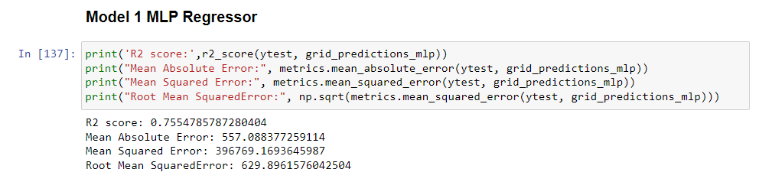

After running the same method to build the models with hyperparameter tuning we can see an improvement with R2 score = 0.76 and RMSE = 629.90.

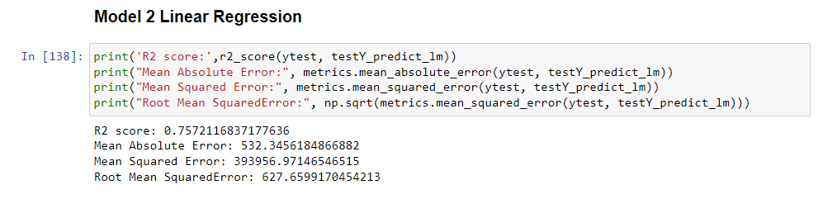

The Linear model also saw improvements with R2 score = 0.76 and RMSE = 627.66. For this model the RMSE is not greatly different from the original linear regression model but the R2 score indicates a greater accuracy in the testing prediction.

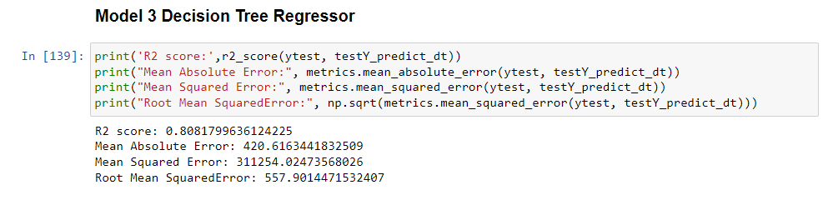

Interestingly, the RMSE of this model actually saw a slight increase indicating greater error. However, the R2 score = 0.81 which is a significant improvement from the previous decision tree model and also the other models built on the new data which were just mentioned.

## Conclusion

To summarise, testing the robustness of the models has been an important step to further validate the model’s generalizability. Introducing a larger cycling dataset proved to be useful in enhancing the model’s accuracy. The dataset that the model was trained achieved strong accuracy with testing accuracy of R2 score = 0.94 for Model 3 – Decision Tree Regressor. When using the smaller dataset that the previous model was built on as a test set this same model produced an accuracy of R2 score = 0.81. From this we can say that Model 3 has improved in robustness and generalizability as accuracy remained at a strong level when testing on new unseen data.

From the research, it does not appear that other companies have attempted to construct a prediction model that focuses on predicting oxygen uptake as a standalone. Instead their focus has been on predicting VO2max as this is seen as a performance indicator and overall health metric that can be compared. Keeping this in mind, the Firstbeat VO2max prediction model achieved an accuracy of 92% for cycling data whereas our model accuracy was 94% for predicting VO2.

**References**

ALTINI, M., VAN HOOF, C. & AMFT, O. 2017. Relation Between Estimated Cardiorespiratory Fitness and Running Performance in Free-Living: an Analysis of HRV4Training Data.

FIRSTBEAT. Automated Fitness Level ( VO 2 max ) Estimation with Heart Rate and Speed Data. 2014.